NORTH-EAST TOUR PACKAGE
GUWAHATI-SHILLONG-KAZIRANGA-MAJULI-SIVASAGAR-DIBRUGARH (11N-12D)
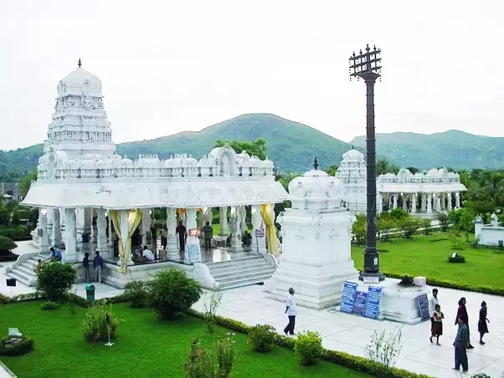
Day 1: Meeting our representative at Guwahati Railway station/Airport after arriving in the morning and drive for the full day city tour- State museum, Science museum, Srimanta Sankardev kalakhetra, Balaji temple, Nabagraha Temple, Dithiol pukhuri, Assam state zoo. Check in hotel and overnight stay.
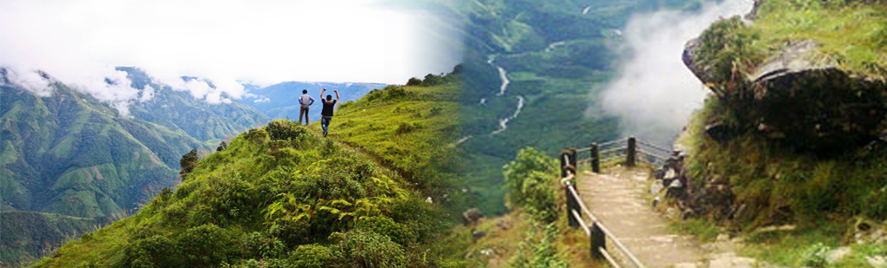
Day 2: After breakfast transfer to Shillong en-route enjoy the view of Umiam Lake (Barapani)- the biggest manmade lake in North-East. Check in Hotel. After refreshment enjoy the half day city tour – Wards lake, Cathedral Catholic Church, Shillong peak, Elephant falls, Lady Hydari Park, Latium canyon. Overnight stay at hotel.
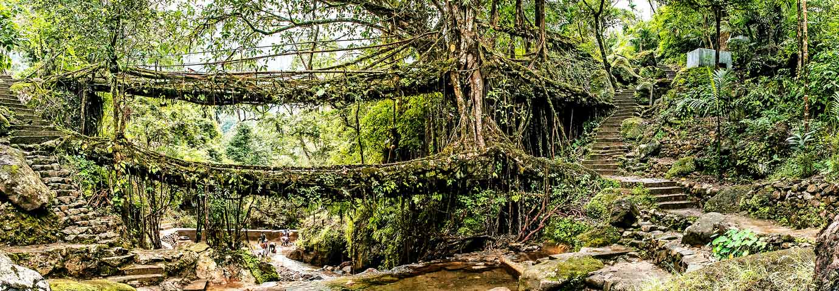
Day 3: After breakfast transfer to Cherrapunjee-the wettest place on the earth. Enjoy the full day trip visiting Seven sister falls, Nohkalikai Falls, Masmai cave, Limestone cave, Thankarang park, Double decker root bridge. Back to Shillong and night stay at hotel.
Day 4: After breakfast Check out hotel and transfer to Kaziranga. Check in hotel and take rest. In the evening enjoy your free time relaxing in the calm and serene atmosphere. Overnight stay at hotel.
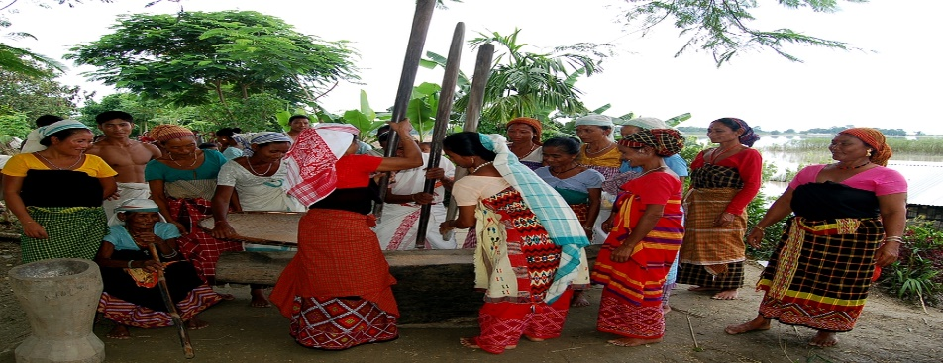
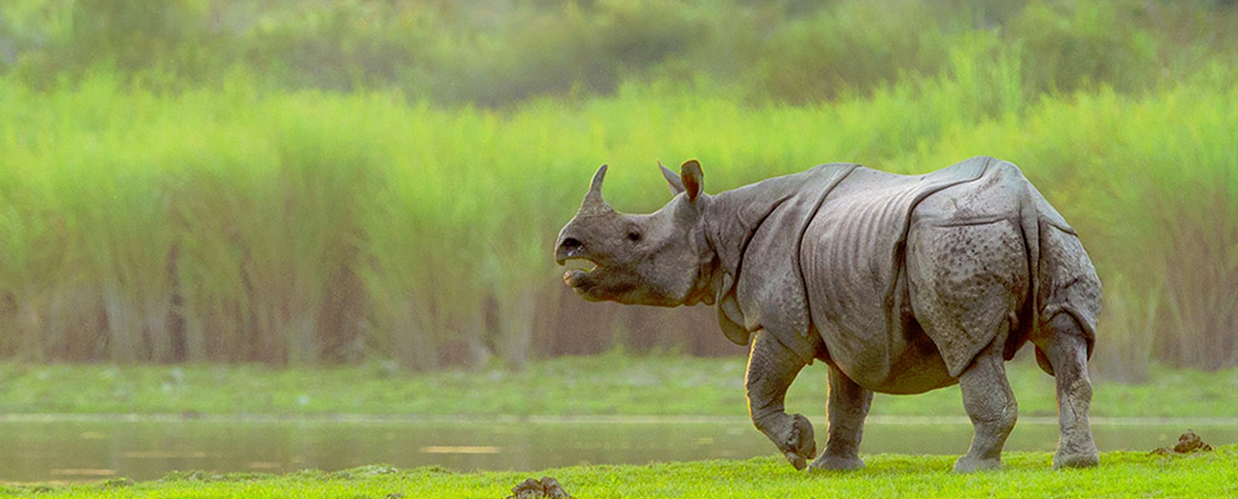
Day 5: In the early morning after breakfast enjoy an elephant safari / a jeep safari at Central range (Kohora) / Western range (Bagori) of Kaziranga National Park. Major attractions are One horned rhino ceros, Indian elephant, Swamp deer, Water buffalo, Hoolock gibbon, Royal Bengal tiger, various species of birds and mammals. Overnight Stay at hotel.
Day 6: Check out hotel and transfer to the Majuli-the biggest river island of the world. Check in hotel. After refreshment visit the Mishing villages to enjoy their ethnic culture. Overnight stay at hotel.
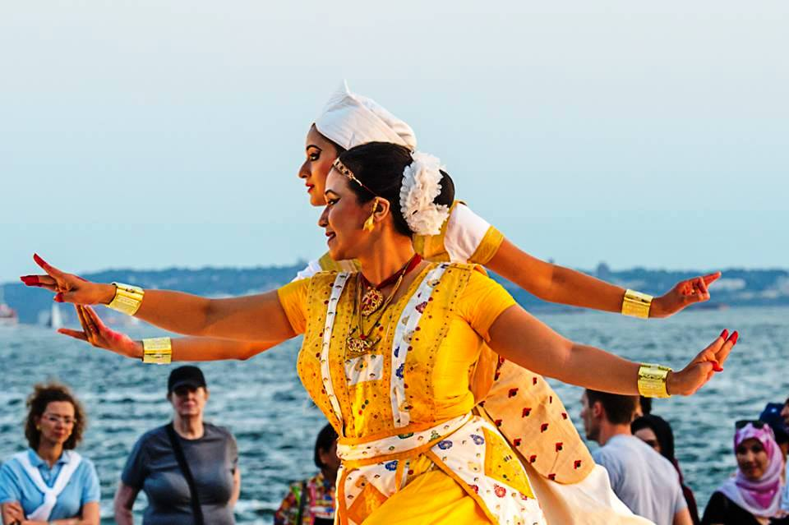
Day 7: After breakfast drive to the full day city tour- Auniati satra, Dakhinpat satra, Kamalabari satra, Bengenati satra, Bhogpur satra, Garamur satra. Vaishnab culture and mask making culture attract tourist mainly. Back to hotel and stay at night.
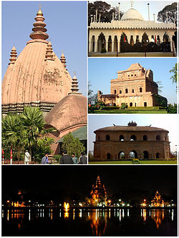
Day 8: After breakfast transfer to Sivasagar- The Ahom Kingdom and go for the half day city tour- Joydol, Joysagar tank, Sibodol, Sibasagar tank. Check in hotel and overnight stay.
Day 9: After breakfast enjoy the day with full day city tour- Talatal Ghar, Kareng ghar, Rang ghar, Charaideo maidams, Tai-Ahom museum, Gaurisagar tank, Rudrasagar, Namdang stone bridge, Panidihing wildlife sanctuary. Overnight stay at hotel.
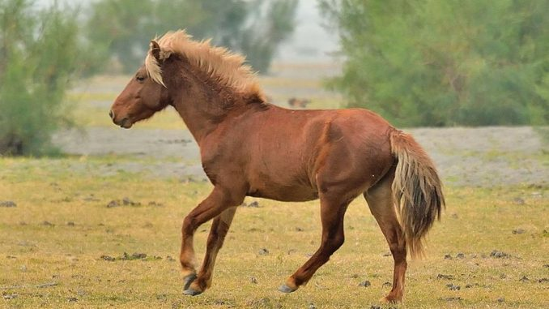
Day 10: After breakfast drive to Dibrugarh. Check in hotel. Enjoy the evening with shopping at Dibrugarh town. Overnight stay at hotel.
Day 11: Early morning transfer to Dibru-Saikhowa National Park. The main attraction of this park is wild horse. Back to hotel and overnight stay at hotel.
Day 12: Check out hotel early in the morning and transfer to Guwahati railway station/airport for the final journey.

